**JOBSHEET 4**

**Brute Force and Divide Conquer**



**Name**

Sherly Lutfi Azkiah Sulistyawati

**NIM**

2341720241

**Class**

1I

**Major**

Information Technology

**Study Program**

D4 Informatics Engineering

**Lab Activity 1: Calculating Factorial Values with Brute Force and Divide and Conquer Algorithms**

**Result**

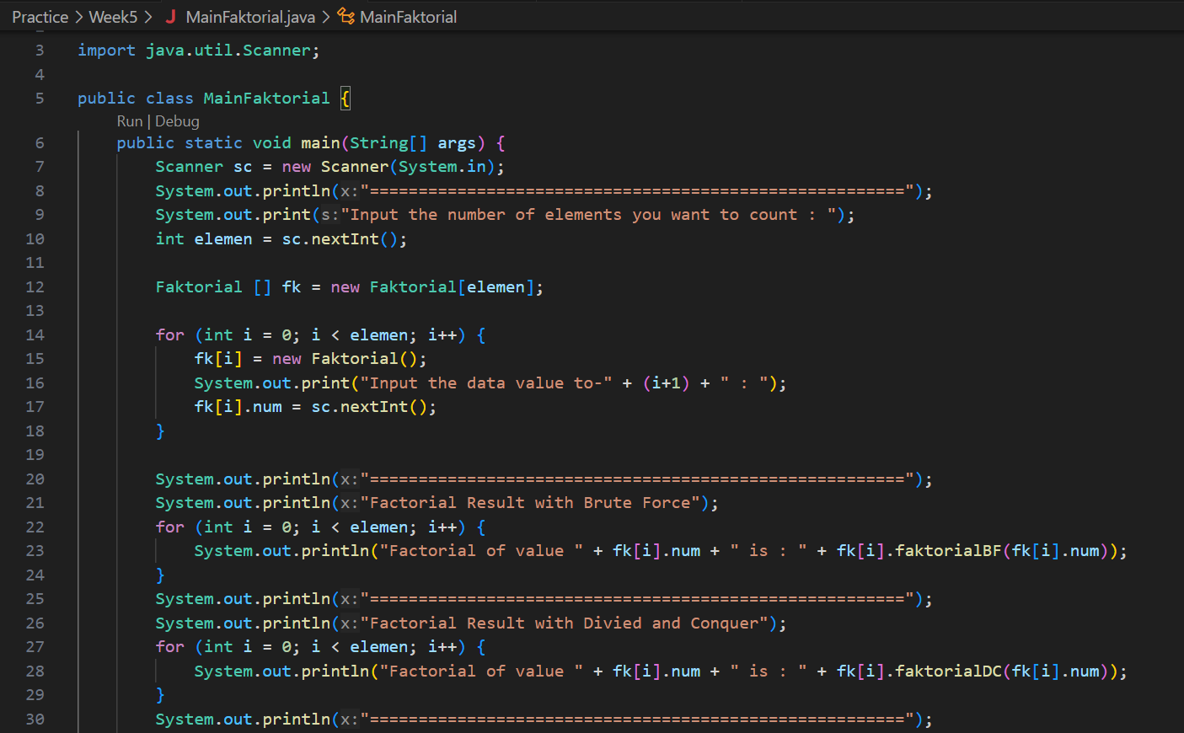

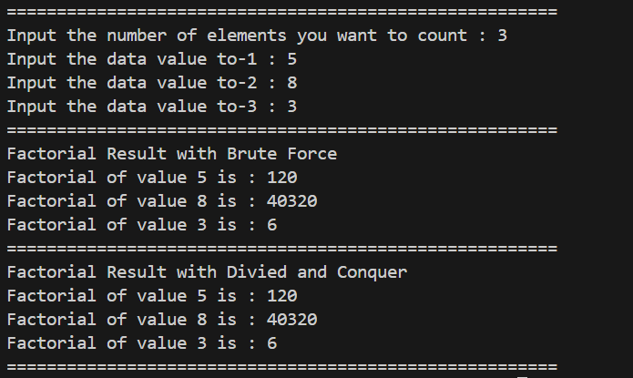

**Question**

1. Explain the Divide Conquer Algorithm for calculating factorial values!
2. In the implementation of Factorial Divide and Conquer Algorithm is it complete that consists of 3 stages of divide, conquer, combine? Explain each part of the program code!
3. Is it possible to repeat the factorial BF () method instead of using for? Prove it!
4. Add a check to the execution time of the two types of methods
5. Prove by inputting elements that are above 20 digits, is there a difference in execution time?

**Lab Activity 2: Calculating Squared Results with Brute Force and Divide and Conquer Algorithms**

**Result**

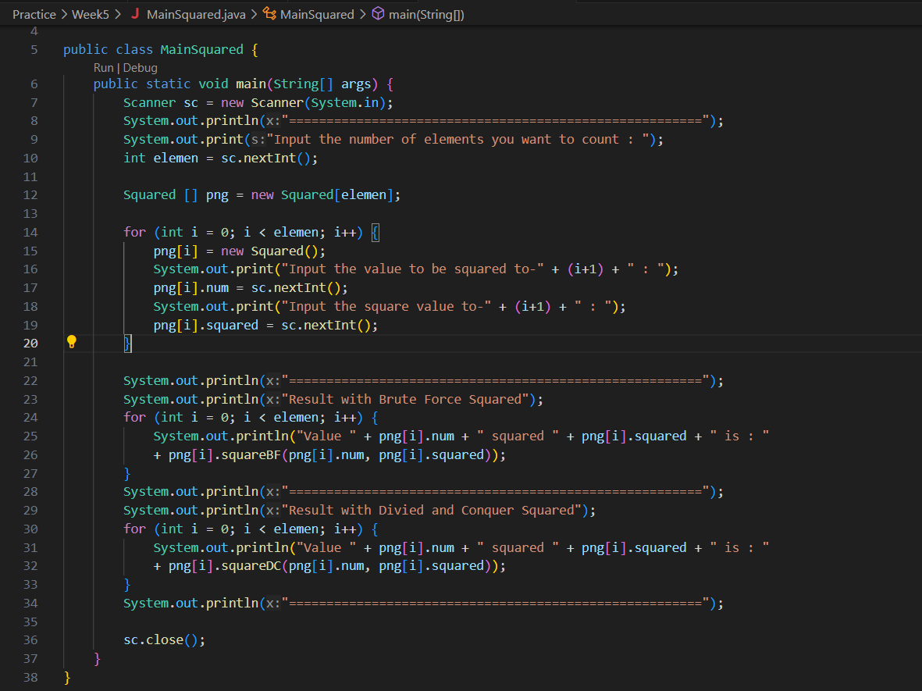

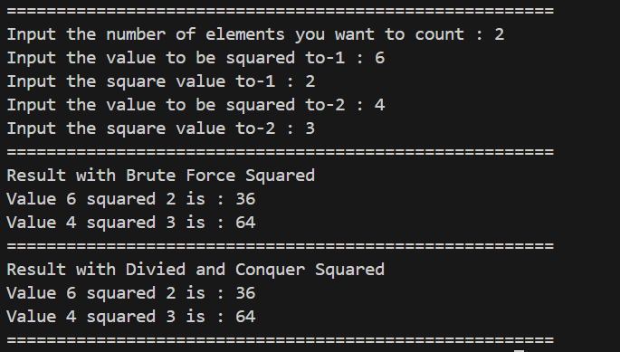

**Question**

1. Explain the differences between the 2 methods made are SquaredBF() and SquaredDC()!
2. In the SuaredDC () method there is a program as follows:

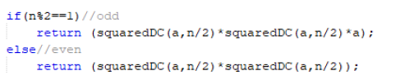

Explain the meaning of the code!

1. Explain whether the combine stage is included in the code!
2. Modification of the program code, assuming the attribute filling process is done by a constructor.
3. Add a menu so that only one of the selected methods will be run!

**Lab Activity 3: Calculating Sum Array with Brute Force and Divide and Conquer Algorithms**

**Result**

**Question**

1. Give an illustration of the difference in profit calculation with the TotalBF () or TotalDC () method.
2. Why is there the following return value? Explain!
3. Why is the mid variable required for the TotalDC () method?
4. The profit calculation program for a company is only for one company. How do you calculate several months of profit for several companies at once (each company can have a different number of months)? Prove it with the program!

**Assignment**

1. Create a program that can calculate the **surface area** and **volume** of a **square pyramid**, and **sphere**. Create 3 (three) classes corresponding to each shape. Create one main class to create an array of objects that inputs the attributes using constructors for all these spatial shapes. With the following provisions:
2. Create a loop to input each attribute, then display the surface area and volume of each type of spatial shape.

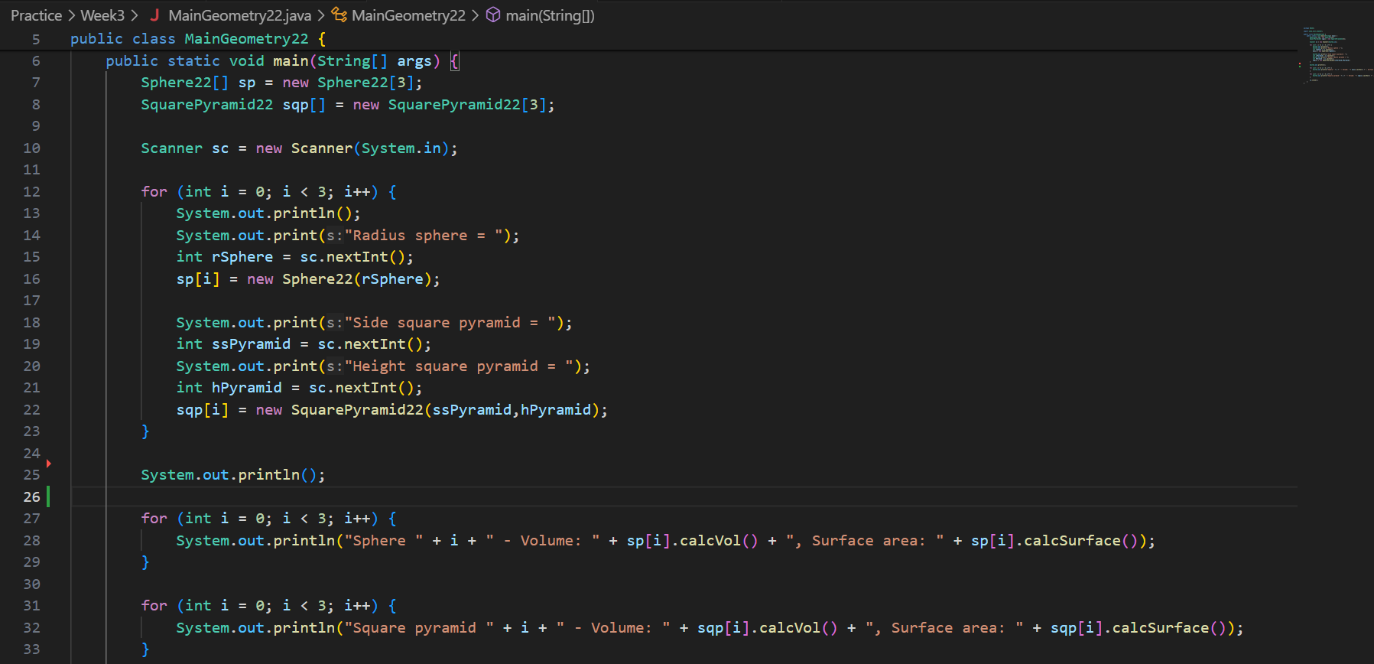

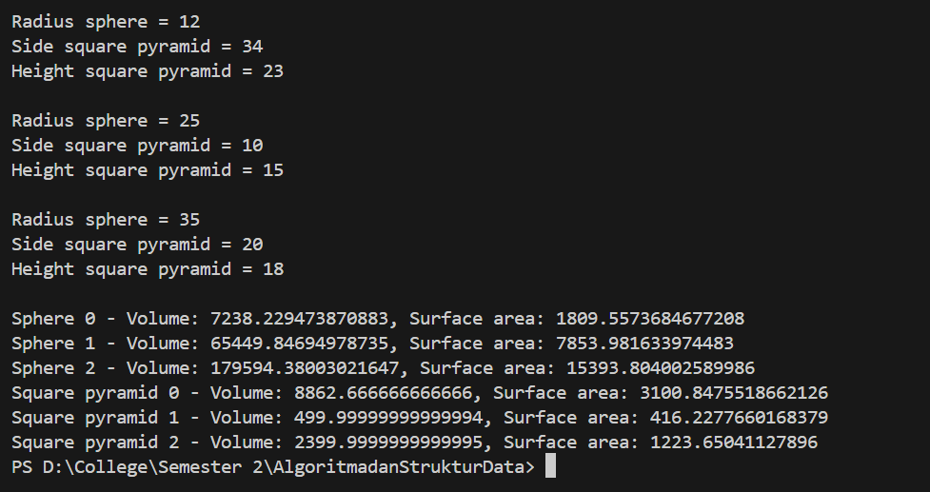

1. For the square pyramid, the input for attributes is only the length of the base side and the height of the pyramid.

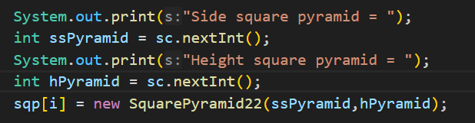

1. For the sphere, the input for attributes is only the radius.

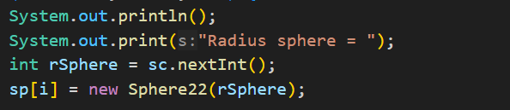

1. A university needs a program to display student’s information such as name, nim, gender, and GPA. This program should be able to receive input from all of those informations and display it to the user. Implement the program if there is 3 data sample, here is a reference of how you do it:

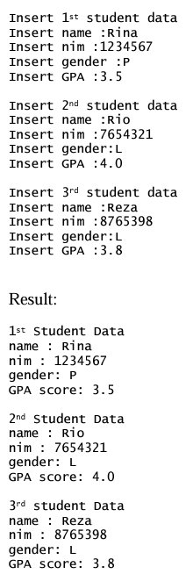

Answer:

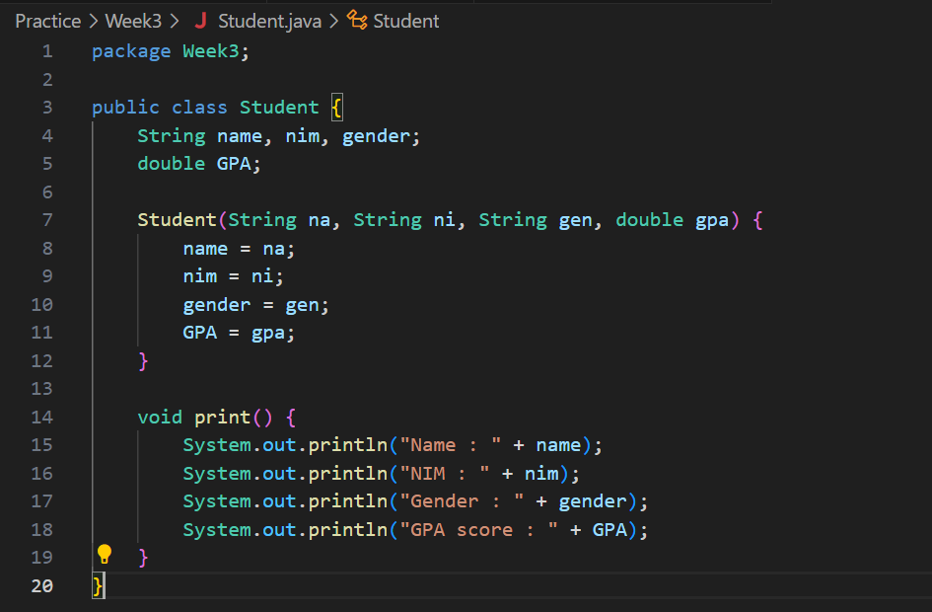

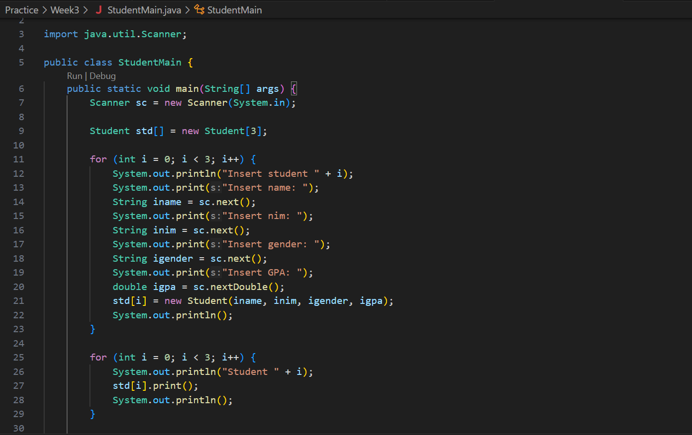

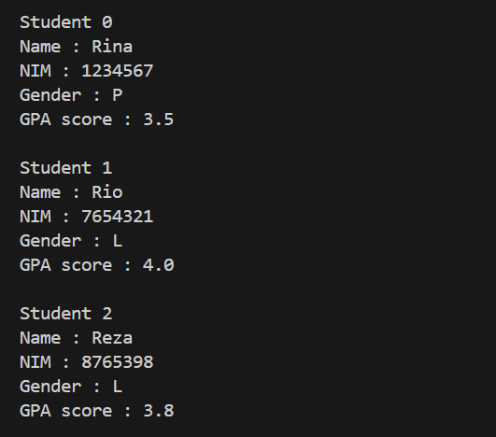

1. Modify the resulting program at no.2, so that it could be used to calculate Average GPA, as well as to display student information that has biggest GPA! (use method to implement each process)

